SIMATS ENGINEERING

ASSESSMENT TOOL 2

COURSE NAME: Database Management Systems COURSE CODE: CSA05

COURSE OUTCOME COVERED

CO1: Analyze DBMS architecture, different data models, schema types, and design ER/EER diagrams, relational schemas for case-based scenarios by identifying entities and relationships. (BL1, BL2)

Activity Tool : Concept Mapping (Medium) Assessment Tool Weightage: 35%

Dr

QUESTIONS Total Marks: 50
Q.No | Question | Bloom's Level | Marks
1 | Construct a concept map linking the following terms: DBMS, Schema, Instance, Data Model, ER Diagram, Entity, Attribute, Relationship. | BL2 – Understand | 5
2 | Create a concept map for the three-level ANSI/SPARC architecture showing data independence at each level. | BL2 – Understand | 5
3 | Map the relationship between file-based systems and database systems, highlighting the problems solved by DBMS. | BL2 – Understand | 5
4 | Design a concept map for ER diagram components: entity, weak entity, attribute types, relationship types, and participation constraints. | BL2 – Understand | 5
5 | Construct a concept map comparing Hierarchical, Network, and Relational data models with their key properties. | BL2 – Understand | 5
6 | Develop a concept map for the EER model showing how it extends the basic ER model with generalization, specialization, and aggregation. | BL2 – Understand | 5
7 | Create a visual concept map for the DBMS software architecture, illustrating the flow from user request to data retrieval. | BL2 – Understand | 5

8 | Map the data models discussed in CO1 to real-world applications and explain the suitability of each model. | BL2 – Understand | 5
9 | Construct a concept map for schemas and instances, showing how they relate to physical and logical data independence. | BL2 – Understand | 5
10 | Design a concept map for the roles and responsibilities in a DBMS environment: DBA, End User, Application Developer. | BL1 – Remember | 5

Code of Conduct:

I Vishal Kruthik (192521179) certify that this submission is my original work and that I have adhered to the guidelines specified for this assessment. I understand that any violation of academic integrity rules will result in disciplinary action.

Signature of the student:

RUBRICS FOR CALCULATION:

Criteria | Weightage | Level 4 (Exemplary) | Level 3 (Proficient) | Level 2 (Developing) | Level 1 (Beginning)
Concept Identification | 25% | Identifies all key concepts from literature accurately and comprehensively | Identifies most key concepts with minor omissions | Identifies limited concepts; some are irrelevant or missing | Fails to identify essential  concepts
Linkages | 25% | Establishes clear, meaningful, and accurate relationships between concepts | Shows correct relationships with minor gaps | Relationships are weak, unclear, or partially incorrect | No meaningful relationships established
Organization | 20% | Concepts are well-structured hierarchically with logical flow and grouping | Mostly organized with minor structural issues | Some organization but lacks clear hierarchy | No logical organization or structure
Integration of Literature | 20% | Integrates multiple studies effectively to  show connections and comparisons | Shows some integration of literature | Limited integration; mostly isolated concepts | No integration of literature evidence

Clarity | 10% | Concept map is clear, neat, visually structured, and easy to interpret | Generally clear with minor readability issues | Clarity is reduced; difficult to interpret in parts | Poorly presented and hard to understand
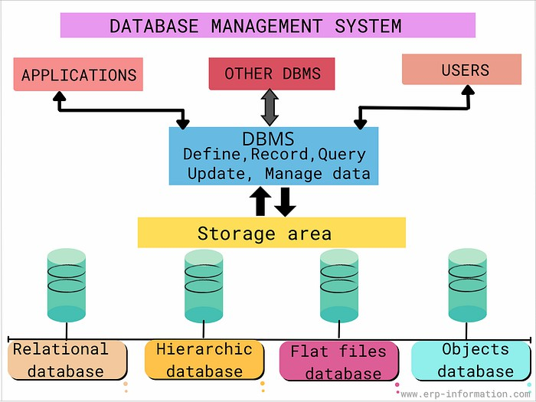

Q1. Concept Map: DBMS, Schema, Instance, Data Model, ER Diagram, Entity, Attribute, Relationship

A DBMS is software that organizes data using a chosen Data Model. The Data Model is described logically through a Schema (the fixed design/structure), while the actual data stored at a given moment is called an Instance (a snapshot that changes as data is inserted, updated, or deleted). The structure of a database is commonly visualized using an ER Diagram, which is built from three basic building blocks:
- Entity – a real-world object or concept (e.g., Student, Course) stored as a table.
- Attribute – a property or characteristic of an entity (e.g., Name, Roll No).
- Relationship – an association between two or more entities (e.g., Student 'enrolls in' Course).
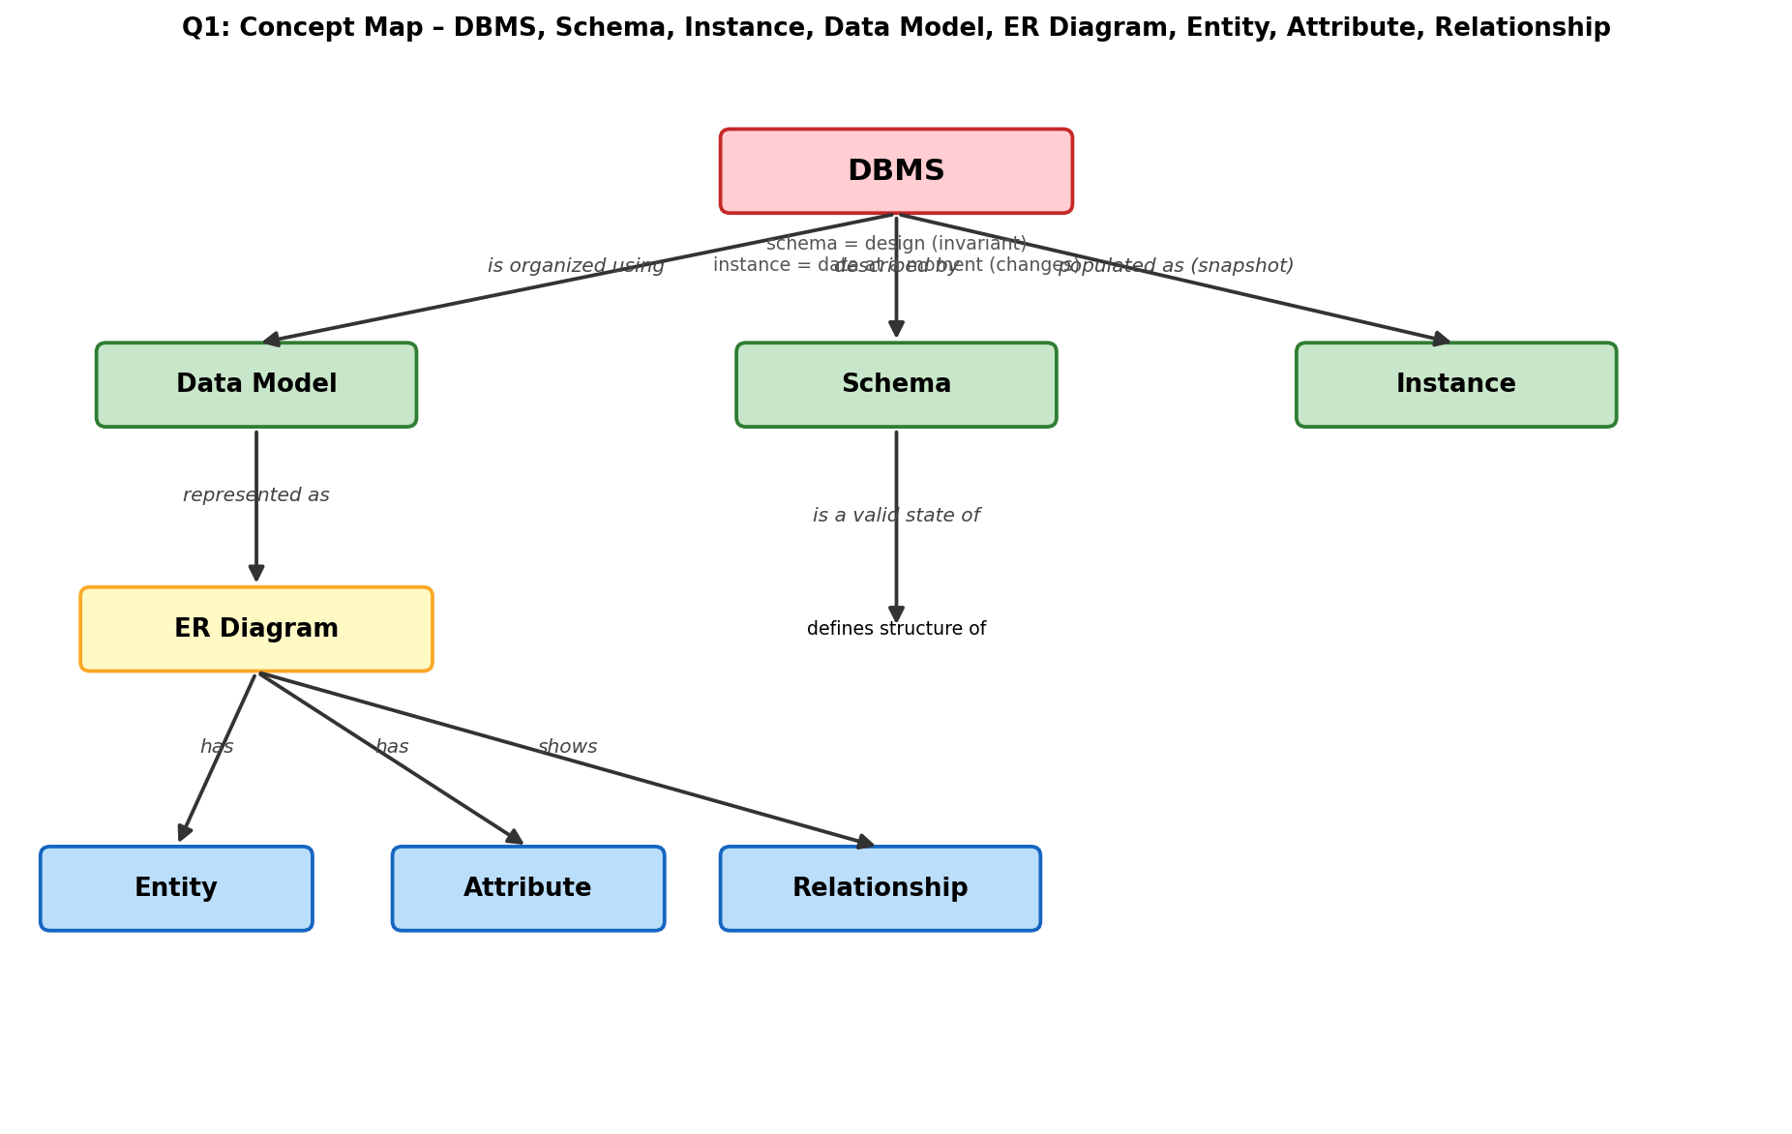

Q2. Concept Map: ANSI/SPARC Three-Level Architecture & Data Independence
Marks: 5
The ANSI/SPARC architecture separates a database into three levels so that changes at one level do not disturb the others:
- External Level – multiple user views, each showing only the data relevant to a specific user or application.
- Conceptual Level – the single logical schema describing the entire database structure, entities, relationships, and constraints, independent of physical storage.
- Internal Level – the physical schema describing how data is actually stored (files, indexes, access paths).
Logical Data Independence allows the conceptual schema to change without affecting external views. Physical Data Independence allows the internal schema to change without affecting the conceptual schema.
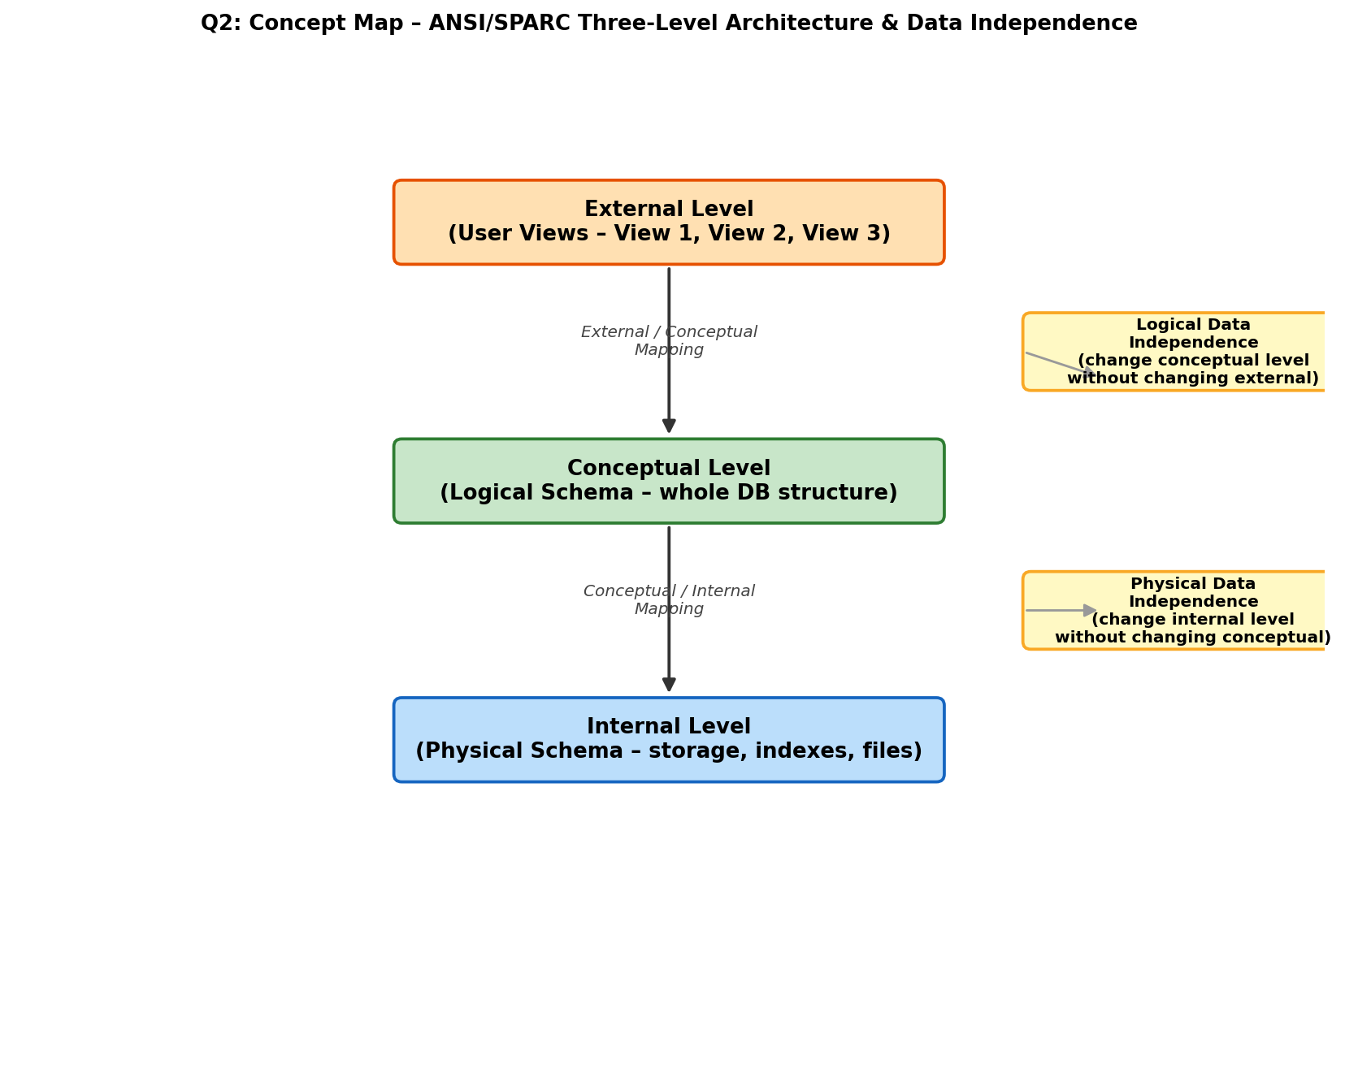

Q3. Concept Map: File-Based Systems vs Database Systems
Marks: 5
In a file-based system, each application maintains its own separate data files, leading to several well-known problems that a DBMS is specifically designed to solve:
- Data Redundancy & Inconsistency → solved by centralized, shared data storage.
- Difficulty in Accessing Data → solved by a query language (SQL).
- Data Isolation (data scattered in different formats) → solved by a unified schema integrating all data.
- Integrity Problems (invalid data) → solved by integrity/consistency constraints.
- Atomicity Problems (partial updates on failure) → solved by transaction management (ACID properties).
- Concurrent-Access Anomalies → solved by concurrency-control mechanisms.
- Security Problems → solved by authorization and access-control features.
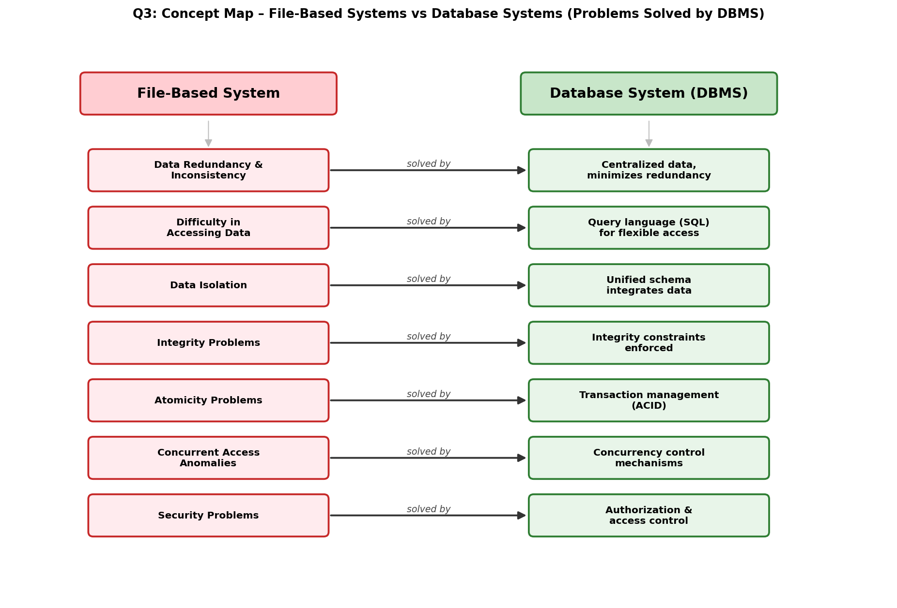

Q4. Concept Map: ER Diagram Components
Marks: 5
An ER diagram is built from four related component groups:
- Entity – Strong Entity (has its own primary key) and Weak Entity (depends on a strong/owner entity for identification).
- Attribute Types – Simple (atomic), Composite (divisible, e.g., Address), Derived (computed, e.g., Age from DOB), Multivalued (multiple values, e.g., Phone Numbers), and Key attribute (uniquely identifies an entity).
- Relationship Types – classified by degree: Unary (1 entity), Binary (2 entities), Ternary (3 entities).
- Participation Constraints – Total participation (every entity instance must participate, shown with a double line) and Partial participation (optional participation, single line).
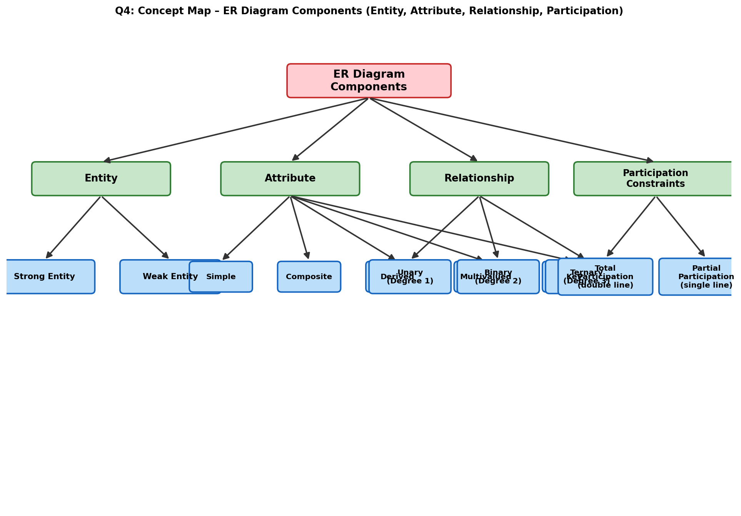

Q5. Concept Map: Hierarchical vs Network vs Relational Data Models
Marks: 5
The three classical data models differ mainly in how they represent relationships between records:
- Hierarchical Model – a tree structure with strict parent–child (1:N) links; each child has exactly one parent; fast but rigid (e.g., IMS).
- Network Model – a graph structure using owner–member sets; a record can have multiple parents, giving more flexibility (e.g., CODASYL/IDMS).
- Relational Model – data stored in tables (relations) of rows and columns; relationships expressed through foreign keys; simple, flexible, and SQL-based (e.g., MySQL, Oracle).
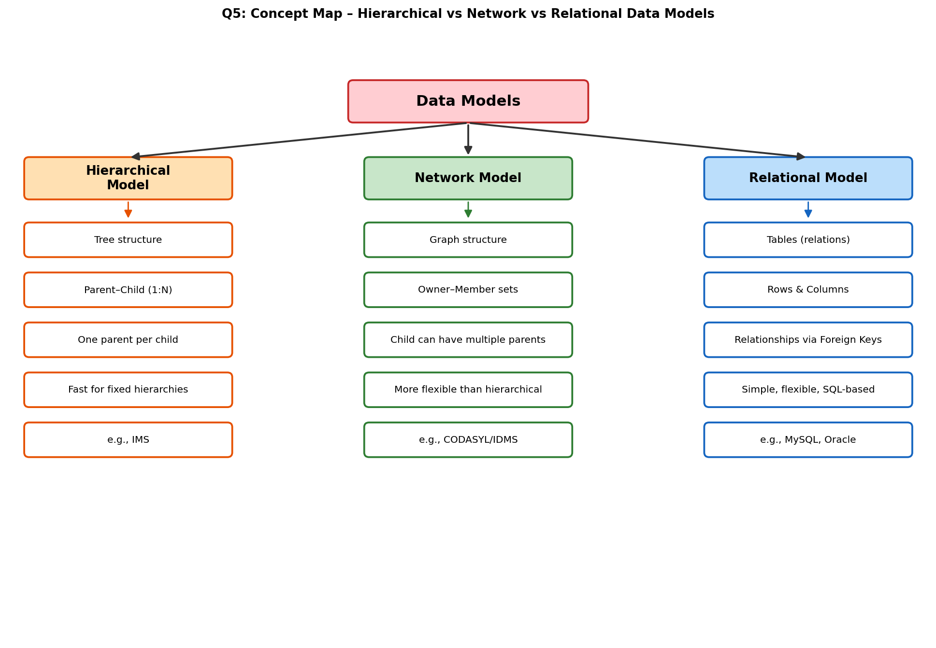

Q6. Concept Map: EER Model — Extending the Basic ER Model
Marks: 5
The Enhanced ER (EER) model adds three powerful abstractions on top of the basic ER model:
- Generalization – a bottom-up process that combines lower-level entities into a higher-level superclass (e.g., Car + Truck → Vehicle).
- Specialization – a top-down process that divides a superclass into specialized subclasses (e.g., Employee → Manager, Engineer), which inherit attributes and relationships from the superclass and may be disjoint/overlapping and total/partial.
- Aggregation – treats a relationship set itself as a higher-level entity, allowing relationships to have their own relationships.
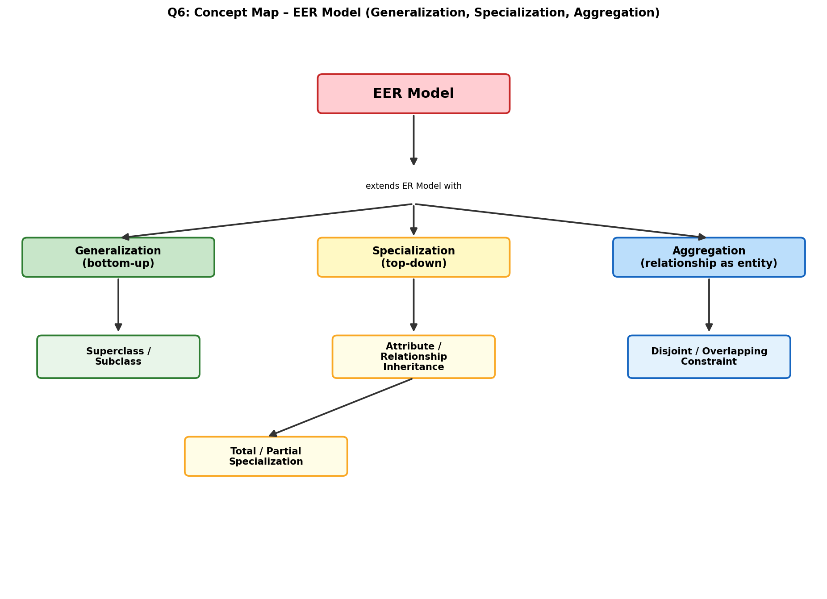

Q7. Visual Concept Map: DBMS Software Architecture (User Request → Data Retrieval)
Marks: 5
When a user or application issues a query, it passes through a defined pipeline inside the DBMS before data is returned:
- User/Application sends an SQL query.
- Query Processor parses and validates the query.
- Query Optimizer selects the most efficient execution plan.
- Execution Engine runs the chosen plan.
- Transaction & Concurrency Control Manager ensures ACID properties and safe multi-user access.
- Storage/Buffer Manager reads and writes data pages from disk.
- Physical Database stores the actual data; the result set is finally returned to the user.
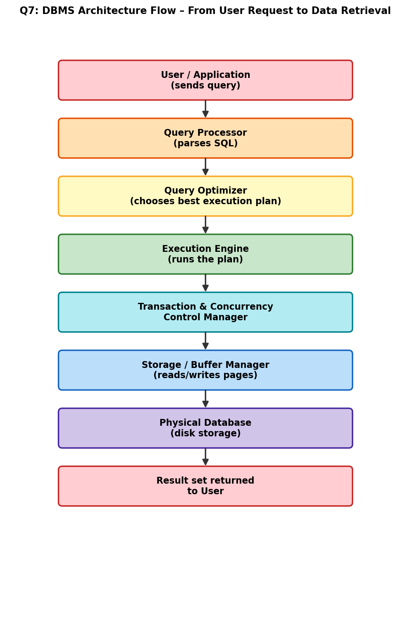

Q8. Concept Map: Data Models Mapped to Real-World Applications
Marks: 5
- Relational Model → Banking, ERP, e-Commerce systems — suited for structured, transactional data with strong consistency needs.
- Hierarchical Model → File systems, XML data, organization charts — suited for naturally tree-structured data.
- Network Model → Airline reservation, telecom systems — suited for complex many-to-many relationships.
- Object-Oriented Model → CAD/CAM, multimedia, engineering design — suited for complex objects with behavior.
- NoSQL/Document Model → Social media, Big Data, real-time analytics — suited for large-scale, semi-structured, rapidly changing data.
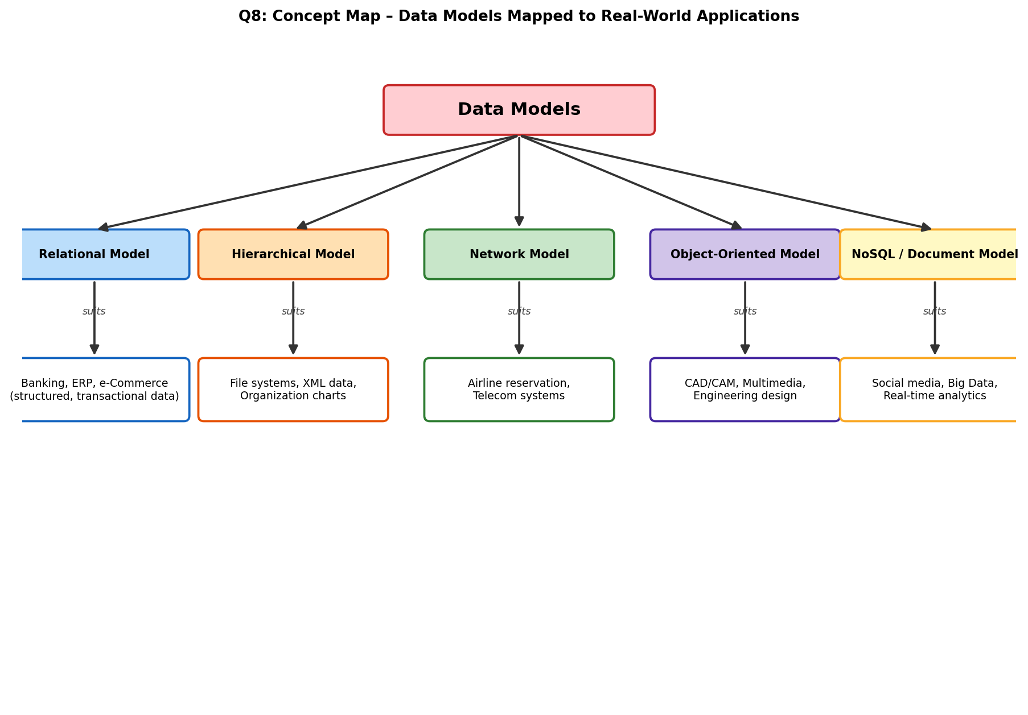

Q9. Concept Map: Schema and Instance vs Data Independence
Marks: 5
A Schema is the overall design/structure of a database (rarely changes), while an Instance is the actual data present at a given moment (changes frequently). The three ANSI/SPARC schemas connect directly to data independence:
- External Schema, Conceptual Schema, and Internal Schema together make up the full database schema.
- Logical Data Independence — the External schema remains unaffected when the Conceptual schema changes.
- Physical Data Independence — the Conceptual schema remains unaffected when the Internal schema changes.
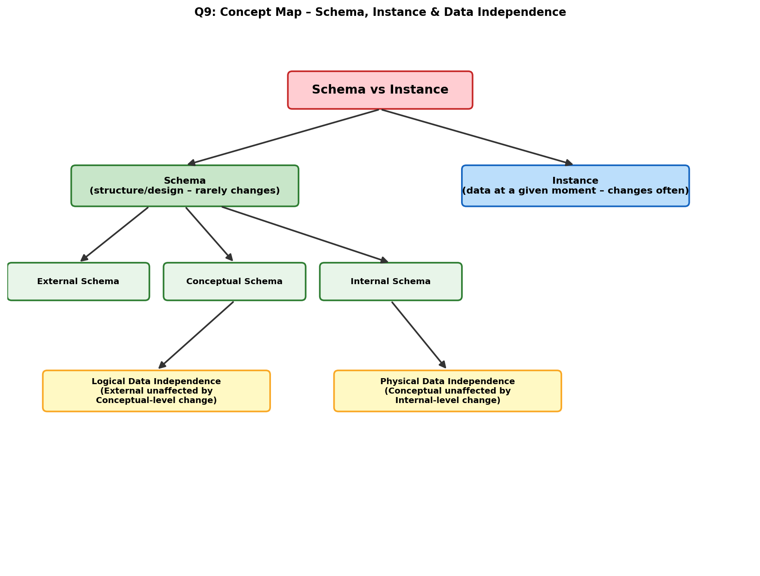

Q10. Concept Map: Roles and Responsibilities in a DBMS Environment
Marks: 5
- Database Administrator (DBA) – defines the schema, manages security, performs backup & recovery, and tunes performance.
- Application Developer – writes programs/interfaces using DML or embedded SQL to interact with the database on behalf of end users.
- End User – interacts with the database through queries or applications; classified as Naive User, Casual User, or Sophisticated User depending on expertise.
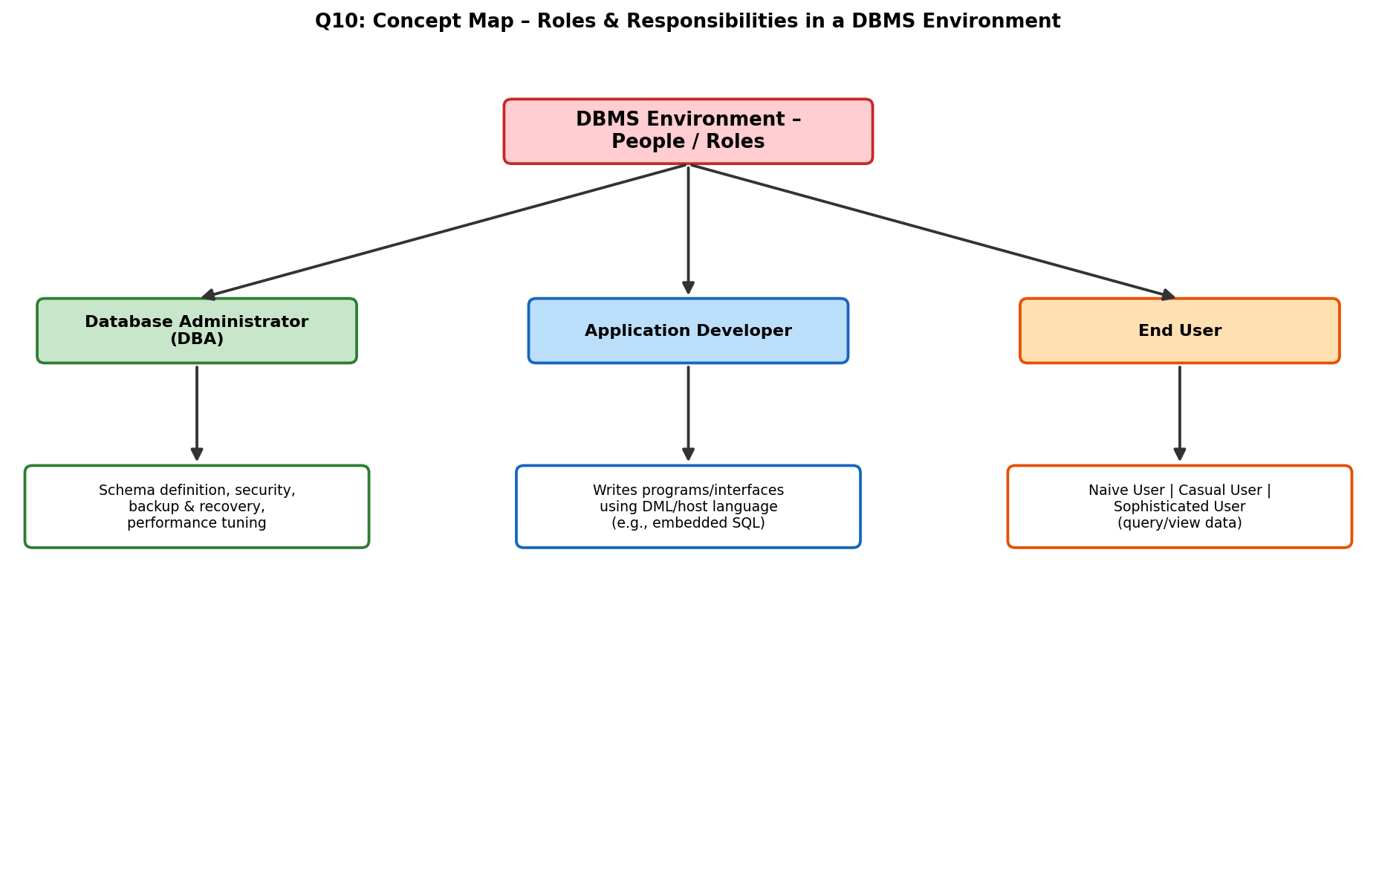

Overall DBMS / ER Architecture Diagram
This diagram summarizes how Applications, other DBMS instances, and Users interact with the DBMS engine (Define, Record, Query, Update, Manage Data), which in turn manages a Storage Area feeding into different database types (Relational, Hierarchic, Flat Files, Objects).
